Lab4 5590
Alex McLaurian
10/6/13

Step 1: I created a small text file, and determined the word count with the built in example for Hadoop. (I did it on an alternate Master Node, as the example seemed to be corrupted on my main master node)

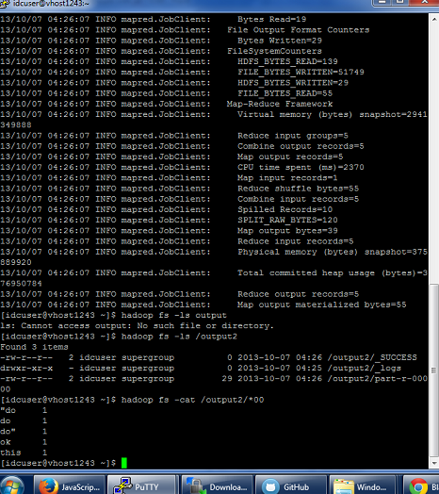

Step 2: After exporting the java project to a jar, I uploaded it to the master node, and ran the wordcount for another small text file.

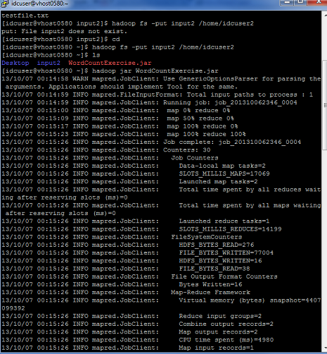

Step 2 results

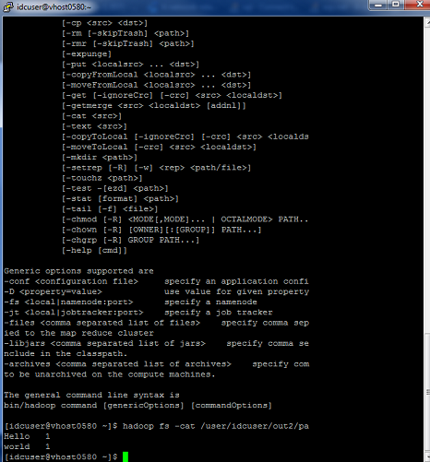

Step 3: I then tested out the alternate version to the wordcount algorithm on this page http://hadoop.apache.org/docs/stable/mapred_tutorial.html.

